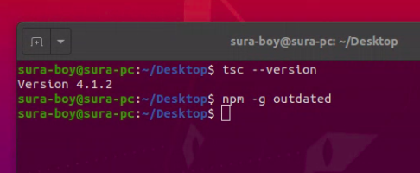

typescript magic → tsc (typescript compiler)

let → came with ecma6

tsconfig.json

for only desktop browsers → ES2015

module → a file, group something, like a class in java
there are so many module loaders
modules came with exma6
loaders – common js, require js(using AMD)

type annotations of type script (like data type in java)
var a: string = ‘ijse’

type inference
look around and search the data type, no need to tell explicitly
var a = ‘ijse’
a = 10 → cannot assign, because string was assigned before
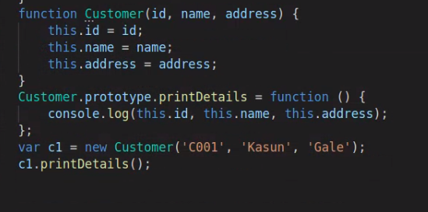

find type declaration
https://www.typescriptlang.org/

ECMA6 module
type=”module” should mention

typescript dont know jquery
need to guide that using type declaration

Primitive data types

symbol → generate unique identifier

